OOPs

Object Oriented Programming

object : object is any real world entity

property or state--🡪 have --🡪 variable / fields

Person name, age, address, phonenumber etc

Behaviour --🡪 do/does -🡪 functions / methods

Teaching, listening, talking etc

User

Animal

Customer

Bank

class : class is a blue print of object or template of object or user defined data types which help to describe the object.

In Java

Ant

Maven or Gradle : these build tool which help to build the project means compile, test, run and creating jar files.

SBT : Scala Build tool :

SBT goal

**clean** : clean old build files

**compile** : it compile all files(.scala) files present your project.

**run** : it run all files

**test**

**package**

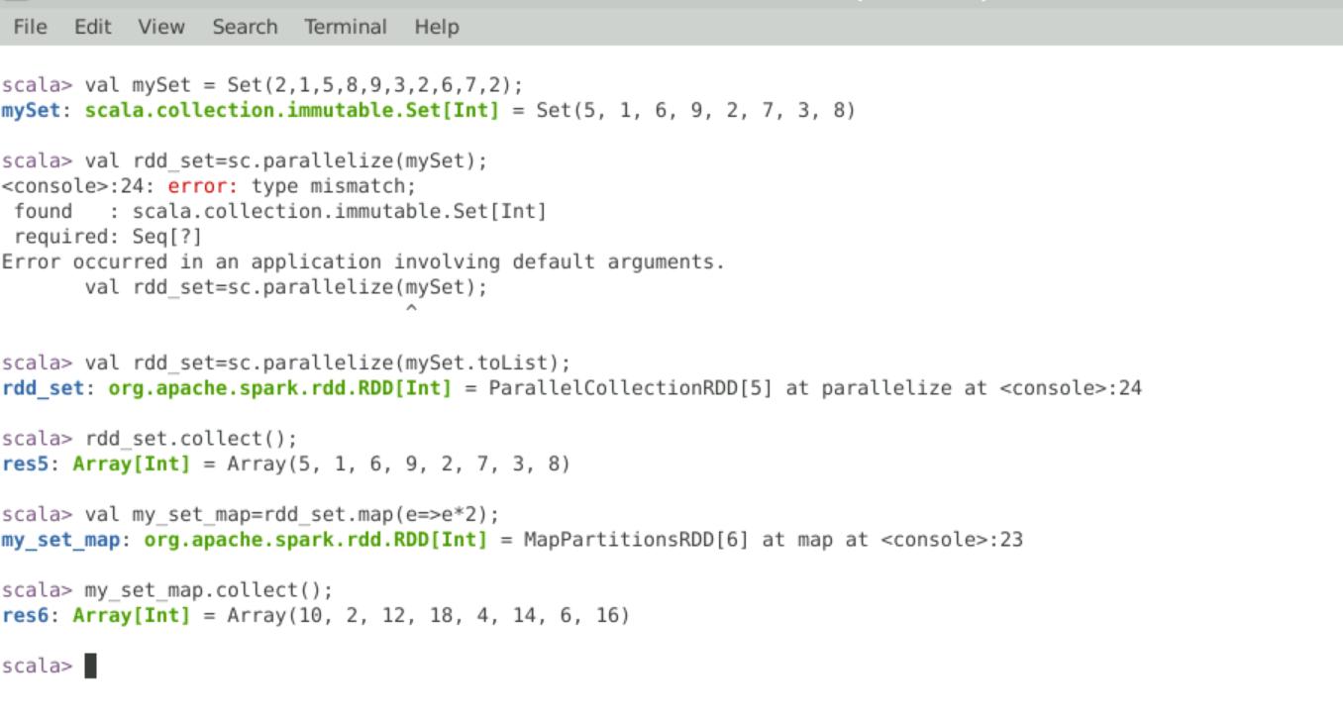

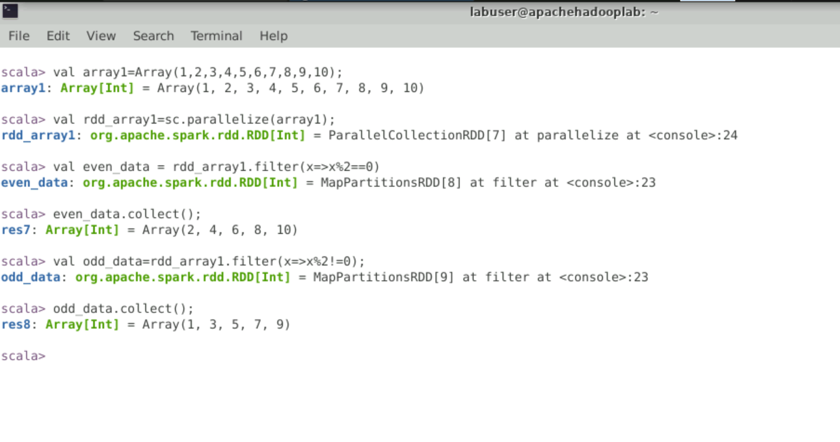

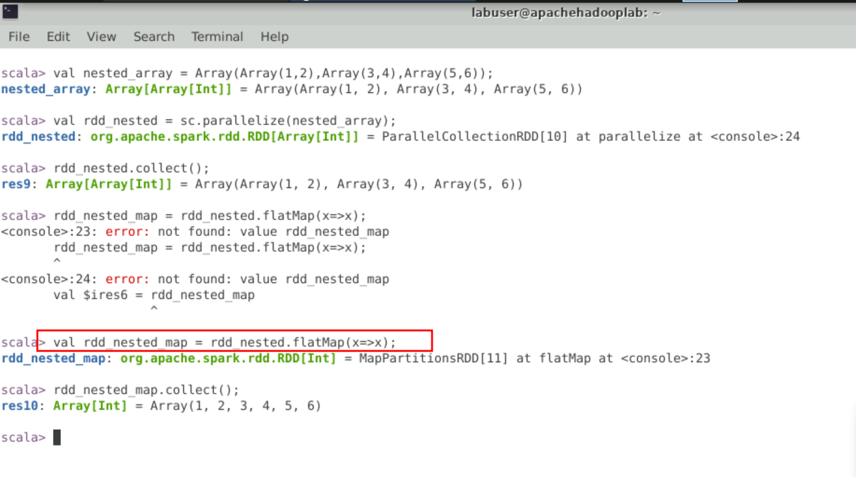

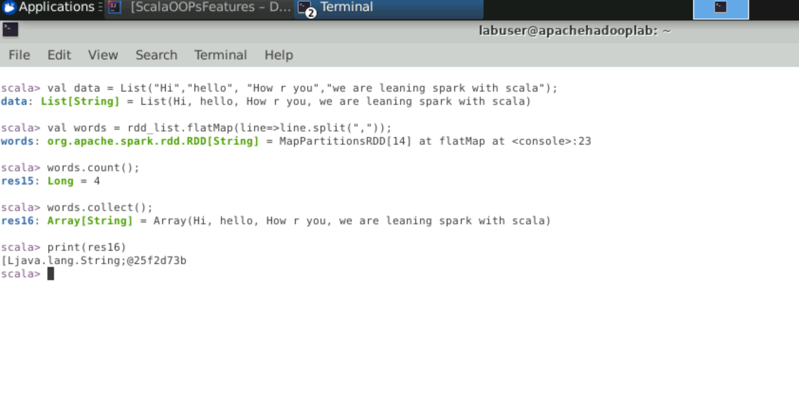

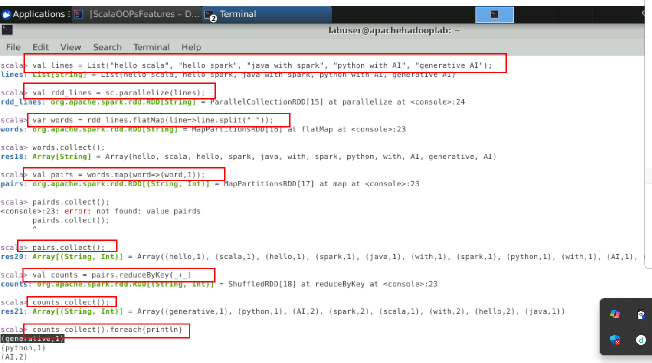

Load the data from file system and convert to RDD then apply any transformation and action functions.

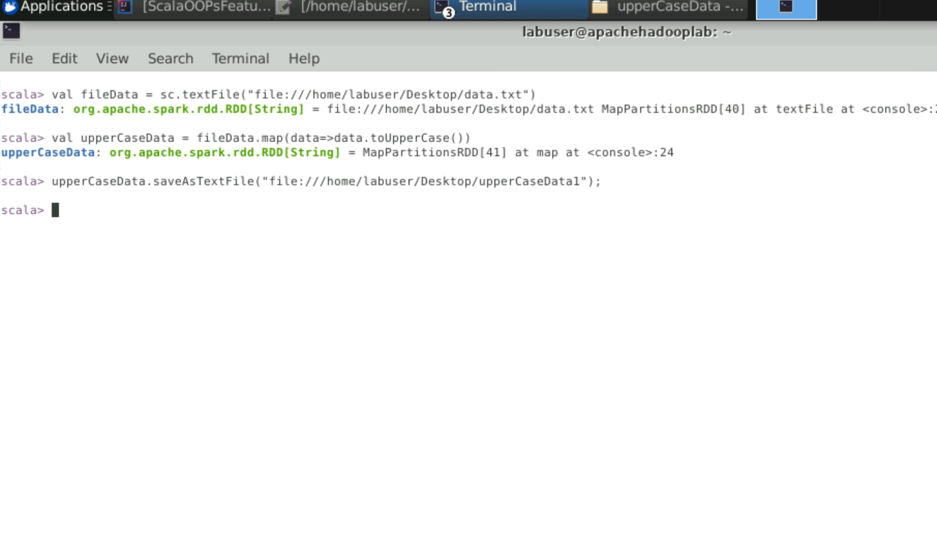

Distinct function

